Programming Concepts  
Week 5 **Credit** Submission Tasks Template

Student ID: ____Mario Stavreski_________________

Student Name: __________103055993____________________

## Credit Task 5 HTML code page

Paste the HTML code of the web page here.

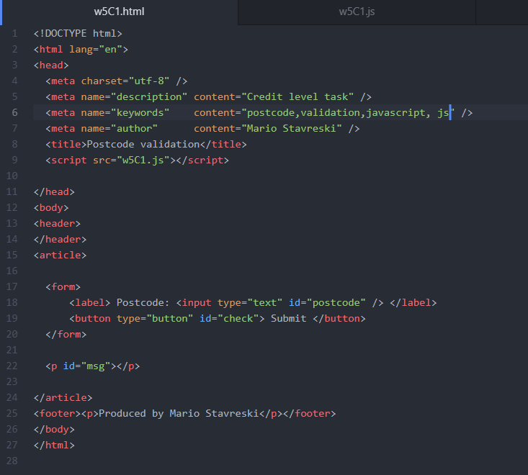

## Credit Task 5 JavaScript code

Paste the JavaScript code of the same page here.

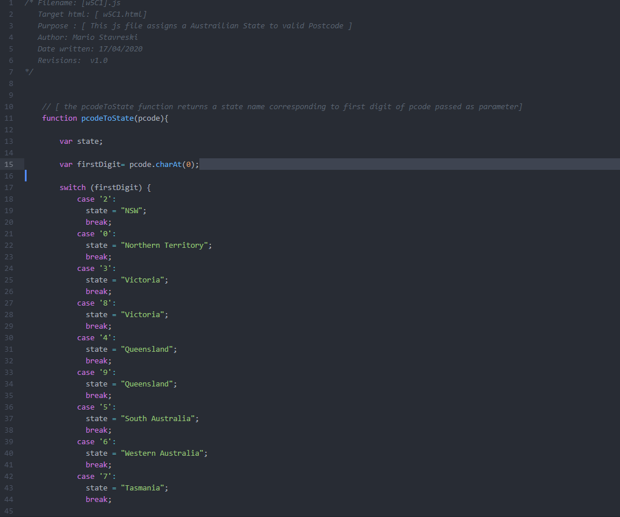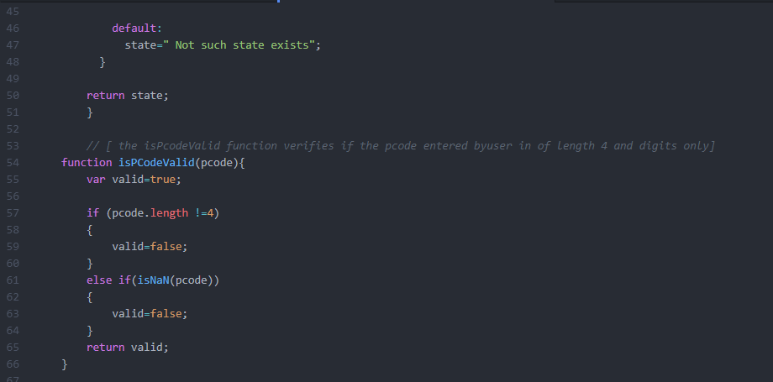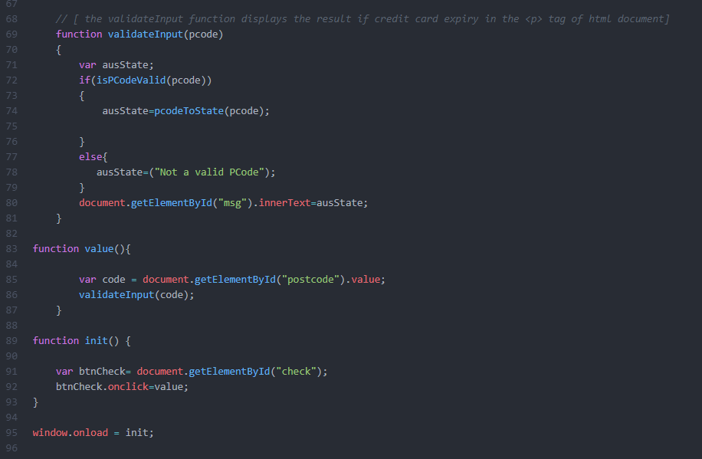

## Credit Task 5 web page testing (10 screenshots, one resulting in “invalid” message and 9 screenshots testing every valid first digit)

Paste the screen captures of your testing web page here.

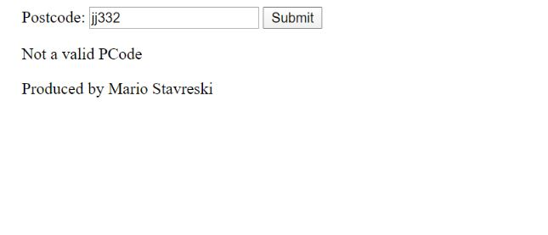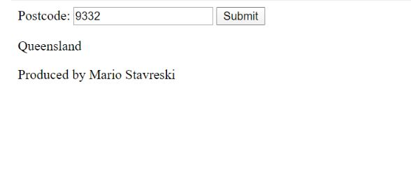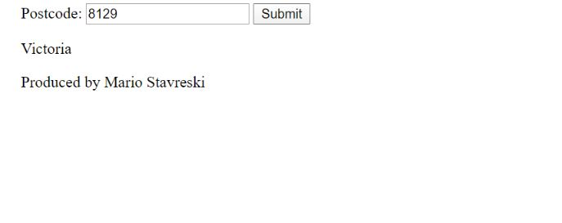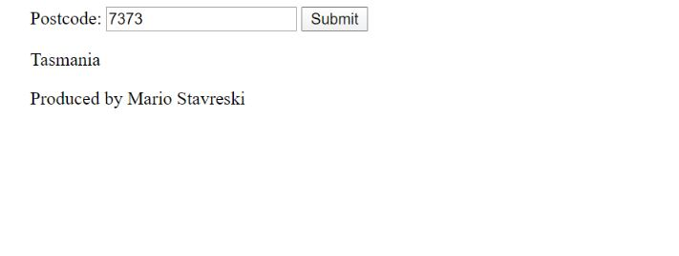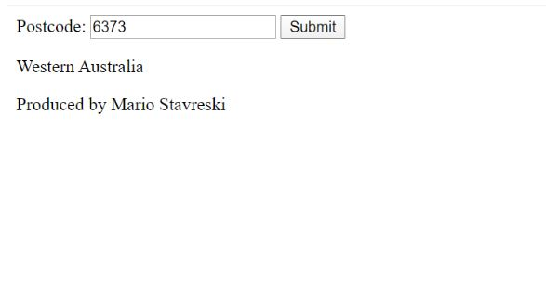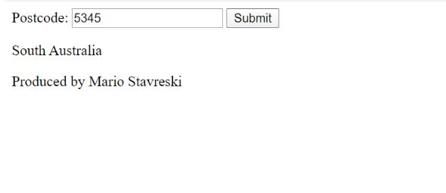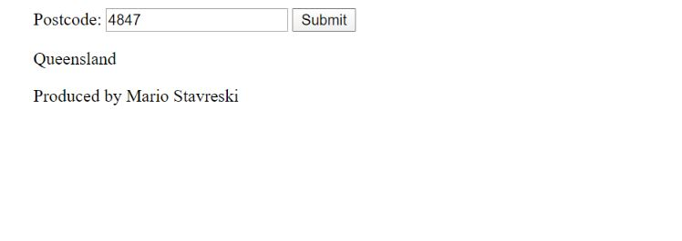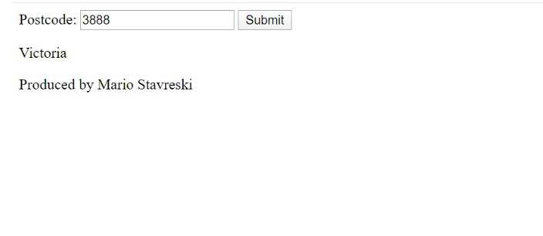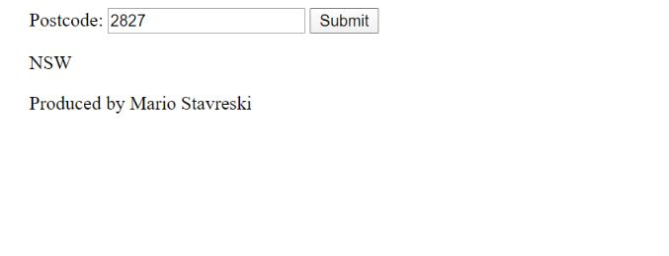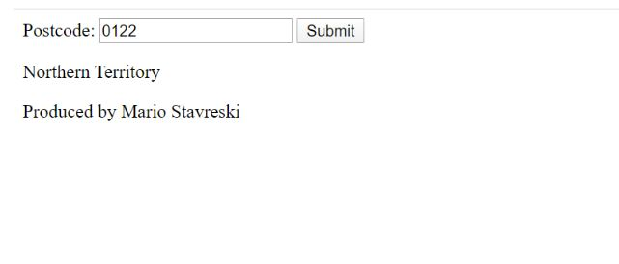

## Credit Task 6 HTML code page

Paste the HTML code of the web page here.

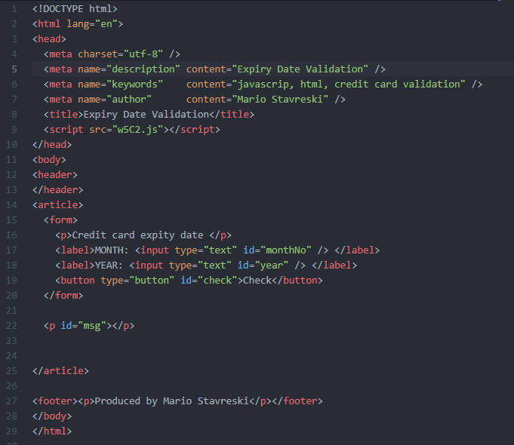

## Credit Task 6 JavaScript code

Paste the JavaScript code of the same page here.

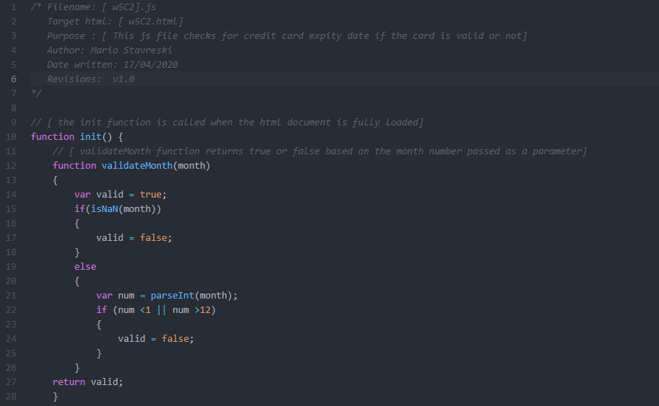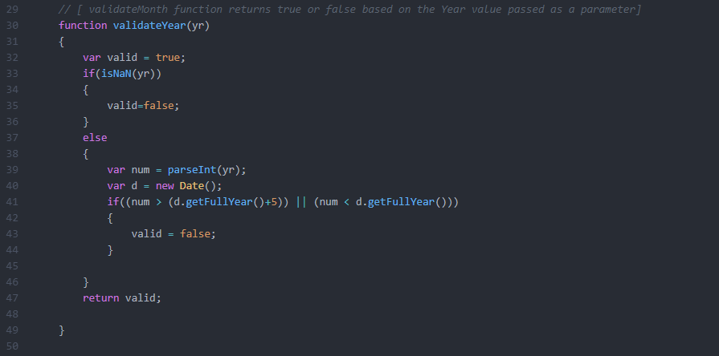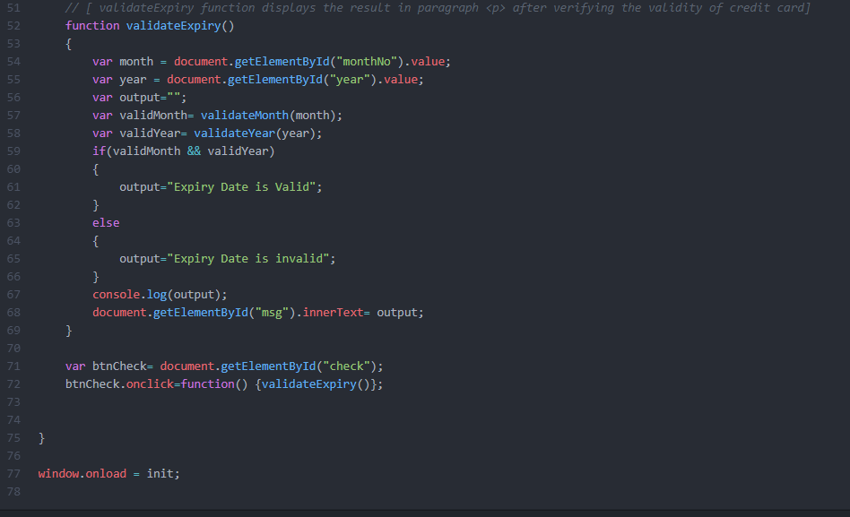

## Credit Task 6 web page testing

Paste the screen captures of your testing web page here.

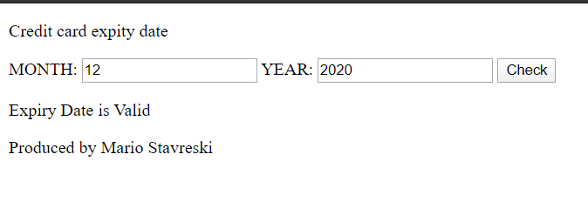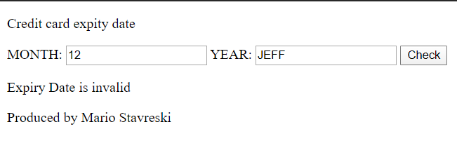

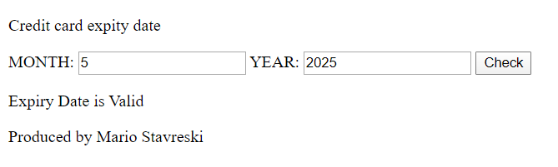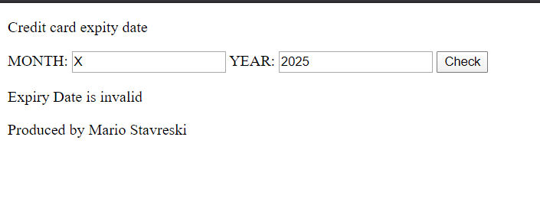

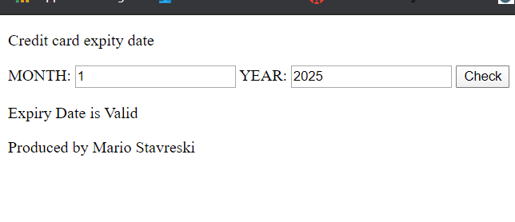

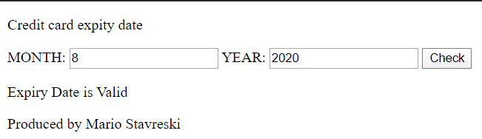

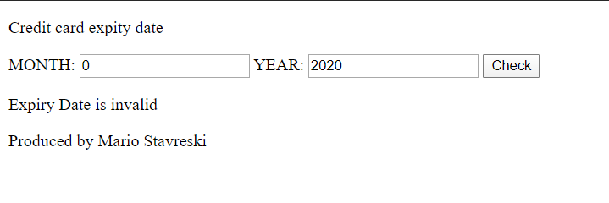

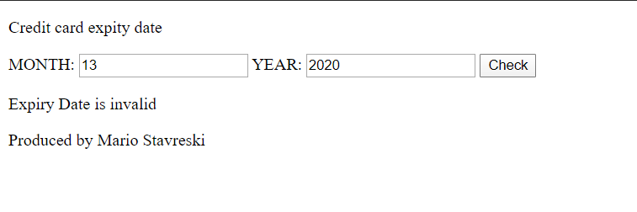

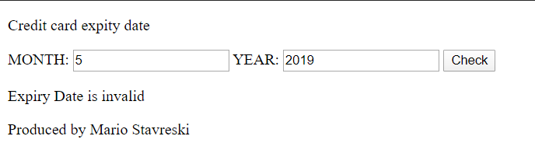

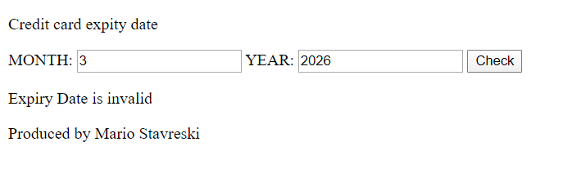

## Credit Task 14 HTML code page

Paste the HTML code of the web page here.

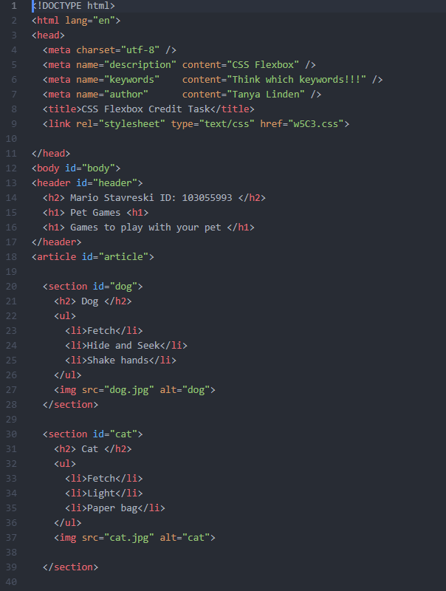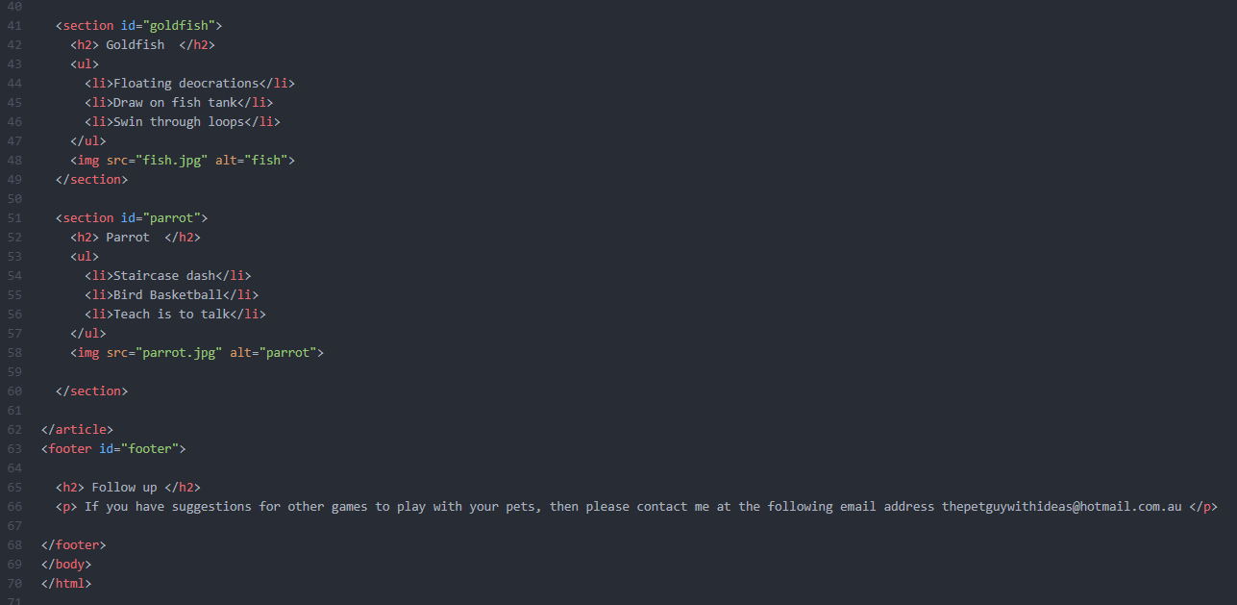

## Credit Task 14 CSS code page

Paste the CSS code of the web page here.

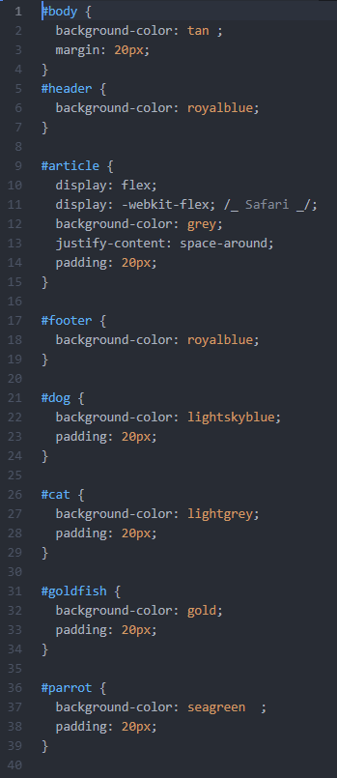

## Credit Task 14 web page screenshot

Paste the screen capture of your web page here.

